TOPIC: When Unlabelled Data Misleads: Rethinking Semi-Supervised Learning Assumptions under Spatial Distribution Mismatch

1. Background and Motivation
Semi-supervised learning (SSL) has gained significant traction due to its ability to leverage both labelled and unlabelled data. Standard SSL methods rely on key assumptions, including:
- The cluster assumption (data points within the same region share labels)
- The manifold assumption
- The low-density separation principle
- Implicit distributional consistency between labelled and unlabelled data
However, in real-world spatial machine learning applications, such as urban analytics, housing studies, environmental modelling, and remote sensing, these assumptions are frequently violated due to:
- Spatial autocorrelation (nearby observations are dependent)
- Spatial heterogeneity / non-stationarity
- Sampling bias, where labelled data are unevenly distributed geographically
- Marginal distribution mismatch, where unlabelled data come from regions not represented in labelled samples
This raises a critical but underexplored question:
When labelled and unlabelled data follow different spatial marginal distributions, do standard semi-supervised learning assumptions break down—and how does this affect model performance?
This research aims to systematically investigate this gap and develop distribution-aware semi-supervised spatial learning methods.
2. Research Aim
To understand and mitigate the effects of marginal distribution mismatch between labelled and unlabelled data on the performance and validity of semi-supervised spatial machine learning models.
3. Research Objectives
- Conceptual Analysis
  - Formalise the role of marginal distribution $P(X)$ mismatch in semi-supervised spatial settings
  - Examine how spatial non-stationarity violates SSL assumptions
- Quantification of Distribution Mismatch
  - Develop metrics for measuring distribution divergence between labelled and unlabelled spatial data
  - Incorporate spatial structure into divergence measures
- Empirical Assessment
  - Evaluate how varying degrees of mismatch affect SSL performance
  - Compare multiple SSL methods under spatial distribution shifts
- Methodological Innovation
  - Design a distribution-aware semi-supervised spatial learning framework
  - Integrate spatial weighting or domain adaptation into SSL
- Application to Real-World Spatial Problems***
  - Demonstrate applicability in domains such as:
    - Housing and built environment
    - Environmental or urban spatial modelling

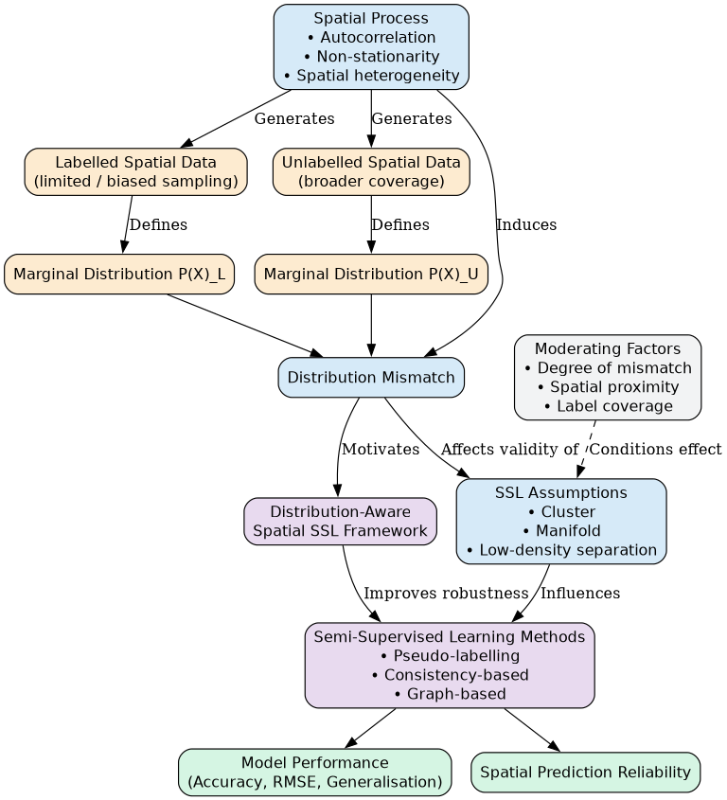
Figure X: Conceptual framework linking marginal distribution mismatch between labelled and unlabelled spatial data to the validity of semi-supervised learning assumptions and model performance. Spatial non-stationarity and autocorrelation act as key drivers of distributional divergence, while proposed distribution-aware approaches aim to mitigate these effects.

4. Research Questions

Primary Question:
- How does marginal distribution mismatch between labelled and unlabelled spatial data affect the performance and assumptions of semi-supervised learning models?

Secondary Questions:
- To what extent do classical SSL assumptions fail under spatial non-stationarity?
- What metrics best capture spatial distribution mismatch?
- Which SSL methods are most robust to such mismatch?
- Can incorporating spatial structure improve SSL under distribution shift?

5. Hypotheses
- H1: Increasing marginal distribution mismatch between labelled and unlabelled spatial data degrades SSL model performance.
- H2: Methods relying strongly on cluster/manifold assumptions are more sensitive to spatial heterogeneity.
- H3: Spatially-aware SSL models outperform standard SSL approaches under distribution mismatch.
- H4: Incorporating distribution alignment or weighting mechanisms mitigates performance loss.

6. Methodology

6.1 Study Design Overview
The study will combine:
- Simulation experiments
- Benchmark dataset evaluation
- Real-world spatial applications

6.2 Data Sources

(a) Synthetic Spatial Data
- Generate spatial datasets with controlled:
  - Autocorrelation
  - Distribution shift across regions
  - Label sparsity patterns

(b) Real-world datasets (examples)
- Housing price or property datasets
- Urban socio-economic indicators
- Environmental monitoring data (e.g., air pollution)

6.3 Measuring Distribution Mismatch
Key metrics:
- Kullback-Leibler (KL) divergence
- Wasserstein distance
- Maximum Mean Discrepancy (MMD)
Spatial extension:
- Localised divergence across geographic regions
- Spatial weighting functions

6.4 Semi-Supervised Learning Methods to Compare
- Baseline methods
  - Self-training / pseudo-labelling
  - Label propagation
- Modern SSL methods
  - Consistency-based (e.g., Mean Teacher, FixMatch-style frameworks)
  - Graph-based methods (GNN-based SSL)
- Spatially explicit models
  - Spatial GNNs
  - Geographically weighted learning models

6.5 Experimental Framework

Step 1: Controlled Experiments
- Vary:
  - Distance between labelled and unlabelled distributions
  - Spatial sampling bias
  - Degree of autocorrelation

Step 2: Performance Evaluation
Metrics:
- Accuracy / RMSE (depending on task)
- Calibration error
- Spatial generalisation error

Step 3: Sensitivity Analysis
- Identify thresholds where SSL assumptions break down

6.6 Proposed Method Development
Develop a Distribution-Aware Spatial SSL Framework:
Key components:
- Distribution alignment module
  - Re-weight unlabelled data based on similarity to labelled distribution
- Spatial weighting mechanism
  - Incorporate geographic distance or spatial kernels
- Adaptive pseudo-labelling
  - Confidence adjusted by spatial and distribution relevance

7. Expected Contributions

Theoretical Contributions
- Formal understanding of SSL assumption violations in spatial contexts
- New insights into interaction between spatial non-stationarity and distribution shift

Methodological Contributions
- Novel spatially-aware semi-supervised learning framework
- Metrics for quantifying spatial distribution mismatch

Practical Contributions
- Guidelines for applying SSL in:
  - Housing research
  - Urban analytics
  - Environmental modelling

8. Significance and Impact
This research addresses a critical and overlooked problem:
The mismatch between theoretical SSL assumptions and real-world spatial data conditions.
Impact:
- Improves reliability of machine learning in spatial sciences
- Reduces risks of biased predictions due to poor label coverage
- Enables more effective use of unlabelled spatial data

